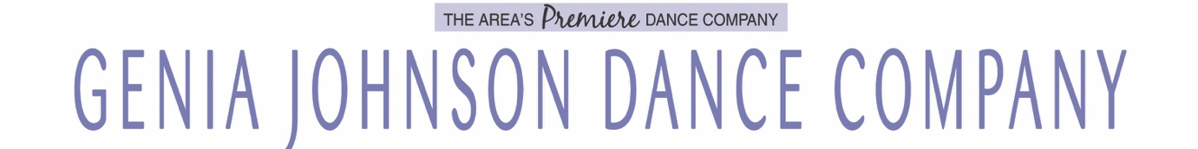

2020-2021 TUITION INFORMATION
WHAT DOES TUITION INCLUDE?
Tuition includes weekly lessons, choreography, Spring Performance costumes and accessories, photography sitting fee & misc. print fees. * Virtual ZOOM classes included with each class. All Combo class tuition includes all of the above as well as an additional costume.
Class Prices
1st Class $756- $84/9 mo. Plan |$63/12 mo. Plan
2nd Class $657- $73/9 mo. Plan |$54.75/12 mo. Plan
3rd + Class $621- $69/9 mo. Plan |$51.75/12 mo. Plan
Combo Classes* (Ballet and Tap Number)
1st Class $882- $98/9 mo. Plan |$73.50/12 mo. Plan
2nd Class $792- $88/9 mo. Plan |$66/12 mo. Plan
Private Lessons $1224 (full year) - $136/9 mo plan OR $40 a class/min. of 4 classes
10 Weeks Session (not available for all classes) $220 - Sept 14-Nov 21, 2020. Costume not included.
Virtual ZOOM Class ONLY (No costume) - $35/month. Virtual lessons only.
Single Class - $35 *First Trial class always free of charge!
Competition Team – Please see Company tuition packet, available during the Team Meeting for pricing information. Email DancinGJDC@aol.com for details.
*Boys are half price! $369, $41/month on a 9 month plan – standard $75 boys costume fee NOT included per class/ number due November 1st.
- First payment is due at registration, which guarantees that student’s spot in that class and is NON-REFUNDABLE.
- Tuition classes are not pay per month. A payment plan is given as an option to split payments up in either a 9 or 12 month plan, instead of paying for the entire tuition up front. The contract drop date has been extended to November 1, 2020 without penalty or being bound to the season’s contract and must be submitted in writing. Every effort will be made to ensure the students wellness and happiness in our school. Please see contract for more detailed information. Attendance and Weather closings do not alter monthly payments.
- There are 2 “Snow Days/Weather Days” built into our dance season. You are NOT paying for those days as they are built into our tuition package. Every effort will be made to make up missed classes if there are more than 2 days we have to close for each class.
- In the event of COVID phase regression/studio closure, and classes must resume with full ZOOM Virtual class, a 20% reduction will be taken off that specific 9 month payment. A similar % will be taken off the 12 month payment option.

